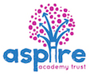

Sandy Hill Academy
Teaching and Learning Principles
Subject: Science

Mission Statement:
‘Aspiring to achieve, determined to succeed’

At Sandy Hill Academy our vision is to provide children with opportunities and experiences to enable them to gain a deeper understanding of the world we live in through a Science curriculum which ignites their curiosity to confidently explore and discover.
In Science we aim to:
- Foster curiosity through personalising and localising science
Children’s enthusiasm and curiosity for science is promoted at every opportunity through linking learning to experiences, aspirations, interests, daily lives and the local area. To enable children to see science as being relevant and important to themselves as an individual.
- Provide high quality Science learning opportunities
To carefully plan lessons and provide opportunities to enable children to acquire key knowledge, vocabulary and working scientifically skills to exceed the expectations of the National Curriculum.
- Inspire
Provide children with opportunities to meet real scientists and engineers to see how STEM subjects are used in the workplace with the aim of inspiring and raising aspirations for future STEM careers.
- Promote talk and deeper thinking
Provide children with opportunities to observe and participate in exciting science investigations to enable them make links with prior learning and ask further questions to deepen their understanding.
- Prioritise practical learning
To provide children with sufficient and engaging activities to enable them to become secure in the required knowledge and allows opportunities for reflection on their learning.
- Health and Well-being
Deliver science learning to promote and support the physical and mental health and
well-being of pupils.
- Talking scientifically
Age appropriate scientific vocabulary to be confidently used and modelled by staff throughout the school day.
- Outdoors
Utilise outdoor areas and the local area to engage children in their learning.

- Partnership
To access resources and CPD from a variety of science organisations (e.g The Ogden Trust and The Royal Chemistry Society) to improve subject knowledge and build on ideas- to ensure we are constantly reflecting on and evolving our Science curriculum. To work in partnership with schools across Aspire to share best practise and organise initiatives to provide for specific groups of children.
- Curriculum enhancement activities
Further inspire and excite children in science learning through a variety of clubs, visiting workshops and school trips.

Science Expections (National Curriculum 2014)
Purpose of study
A high-quality science education provides the foundations for understanding the world through the specific disciplines of biology, chemistry and physics. Science has changed our lives and is vital to the world’s future prosperity, and all pupils should be taught essential aspects of the knowledge, methods, processes and uses of science. Through building up a body of key foundational knowledge and concepts, pupils should be encouraged to recognise the power of rational explanation and develop a sense of excitement and curiosity about natural phenomena. They should be encouraged to understand how science can be used to explain what is occurring, predict how things will behave, and analyse causes.
Aims
The national curriculum for science aims to ensure that all pupils:
- develop scientific knowledge and conceptual understanding through the specific disciplines of biology, chemistry and physics
- develop understanding of the nature, processes and methods of science through different types of science enquiries that help them to answer scientific questions about the world around them
- are equipped with the scientific knowledge required to understand the uses and implications of science, today and for the future.
The nature, processes and methods of science
‘Working scientifically’ specifies the understanding of the nature, processes and methods of science for each year group. It should not be taught as a separate strand. The notes and guidance give examples of how ‘working scientifically’ might be embedded within the content of biology, chemistry and physics, focusing on the key features of scientific enquiry, so that pupils learn to use a variety of approaches to answer relevant scientific questions. These types of scientific enquiry should include: observing over time; pattern seeking; identifying, classifying and grouping; comparative and fair testing (controlled investigations); and researching using secondary sources. Pupils should seek answers to questions through collecting, analysing and presenting data. ‘Working scientifically’ will be developed further at key stages 3 and 4, once pupils have built up sufficient understanding of science to engage meaningfully in more sophisticated discussion of experimental design and control.

EYFS
Science in EYFS is covered in the ‘Understanding the World’ area of the EYFS Curriculum. It is introduced indirectly through activities that encourage your child to explore, problem solve, observe, predict, think, make decisions and talk about the world around them.

ELG- The World
Children know about similarities and differences in relation
to places, objects, materials and living things. They talk about the features of their own immediate environment and how environments might vary from one another. They make observations of animals and plants and explain why some things occur, and talk about changes.

Early Years Science also helps children with skills in other Foundation Stage areas of the National Curriculum, such as Physical Development and Expressive Arts and Design. During their first year at school your child will explore creatures, people, plants and objects in their natural environments. They will observe and manipulate objects and materials to identify differences and similarities. For example, they may look at an egg whisk, sand, paper and water to learn about things that are natural and manmade and their different functions. They will also learn to use their senses, feeling dough or listening to sounds in the environment, such as sirens or farm animals. They will make observations of animals and plants and explain why some things occur and talk about changes.
Children will be encouraged to ask questions about why things happen and how things work. They might do activities such as increasing the incline of a slope to observe how fast a vehicle travels and opening a mechanical toy to see how it works. Children will also be asked questions about what they think will happen to help them communicate, plan, investigate, record and evaluate findings.
We use Tapestry, our online learning journal, to record and track children’s progress and achievements in Science against the Early Learning Goals. Children who need additional help are identified and interventions put in to place when appropriate. Children’s progress within Science is then reported to parents through: settling in meetings, sharing learning journals and regular communication. In line with statutory requirements children are assessed against the Early Learning Goals for ‘Understanding the World’ at the end of the Reception year and this is reported to the LA and parents.

KS1 and KS2 Key Objectives

Year 1
- Use different approaches to answer scientific questions
- Carry out simple tests
- Organise objects or materials into groups
- Name the main parts of plants and trees
- Name the main parts of the body, including those related to the five senses
- Distinguish between an object and the material from which it is made
- Describe the simple physical properties of a variety of everyday materials
- Describe how the weather varies with the season

Year 2
- Use simple equipment for observations
- Link ideas and answers to observations
- Collect information to help to answer scientific questions
- Describe how some plants and animals are suited to different habitats
- Describe how animals obtain food by eating plants or other animals
- Describe the basic needs for plant growth (light, water, appropriate temperature)
- Describe the basic needs of humans and other animals (water, food, air)
- Describe the different uses of materials according to their properties.
Year 3
- Set up simple fair tests
- Collect and present data from scientific experiments
- Use results from experiments to draw simple conclusions or suggest improvements
- Describe the main requirements for plant growth (air, light, water, nutrients from soil, room to grow)
- Explain the main stages of plant reproduction (pollination, fertilisation, seed dispersal)
- Explain some functions of skeletons and muscles in animals
- Identify the three main rock types and describe their properties
- Notice that light is reflected from surfaces
- Find patterns in the way that the sizes of shadows change
- Group materials according to their magnetic properties

Year 4
- Take accurate measurements using a range of scientific apparatus
- Present findings using tables, graphs and charts as appropriate
- Use straightforward evidence in the support of ideas
- Use a classification key to identify plants or animals
- Describe the simple functions of the basic parts of the digestive system in humans
- Construct and interpret a variety of food chains, identifying producers, predators and prey
- Compare and group materials together according to whether they are solids, liquids or gases
- Explain the main stages of the water cycle
- Recognise that vibrations from sounds travel through a medium to the ear
- Construct a simple series electrical circuit, identifying and naming its basic parts

Year 5
- Plan scientific investigations, including controlling variables where appropriate
- Record data using diagrams, keys, tables and a range of graphs
- Record conclusions and explanations from scientific investigations
- Describe the life process of reproduction in some plants and animals
- Explain how mixtures can be separated through filtering, sieving and evaporating
- Explain that some irreversible changes form new materials
- Describe the movement of the Earth and other planets, relative to the sun
- Explain day and night on earth and the apparent movement of the sun
- Explain that gravity causes unsupported objects to fall towards the Earth
- Identify the effects of air resistance, water resistance and friction moving between surfaces

Year 6
- Use test results to design further investigations
- Using simple models to describe scientific ideas
- Identifying scientific evidence that has been used to support or refute ideas or arguments
- Classify some plants, animals or micro-organisms, explaining the choices made
- Explain the main parts and functions of the human circulatory system, including heart and blood vessels.
- Recognise that living things produce offspring which are not usually identical to their parents
- Identify how adaptation of plants and animals over time may lead to evolution
- Explain that we see things which either give out or reflect light
- Explain how the number or voltage of cells affects bulbs, buzzers or motors in a circuit.
- Use recognised symbols when representing a simple circuit in a diagram.

Planning
Teachers plan their lessons to ensure that topics are covered in line with the National Curriculum.
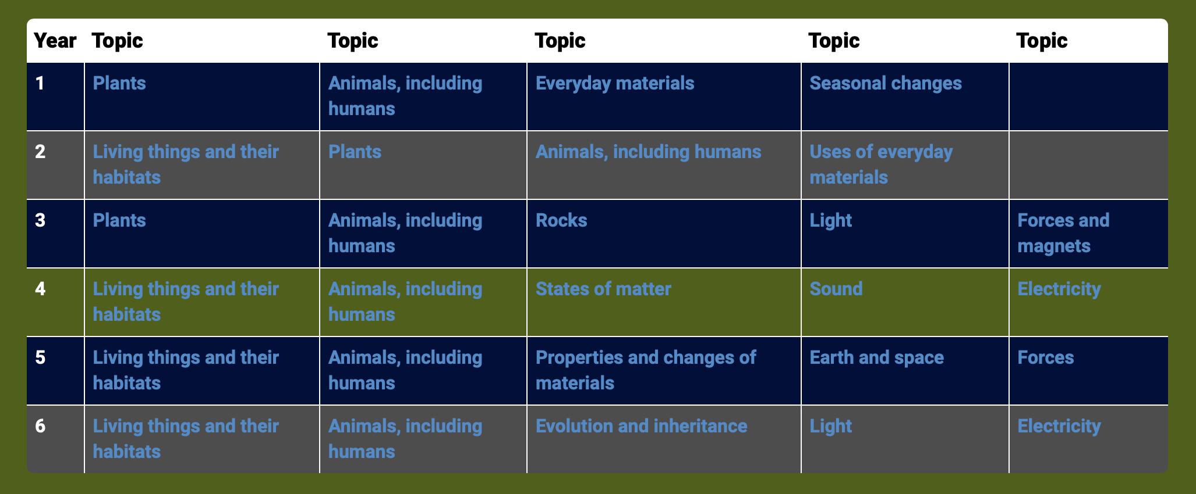

An example of planning for a Year 3 unit – Animals, including Humans
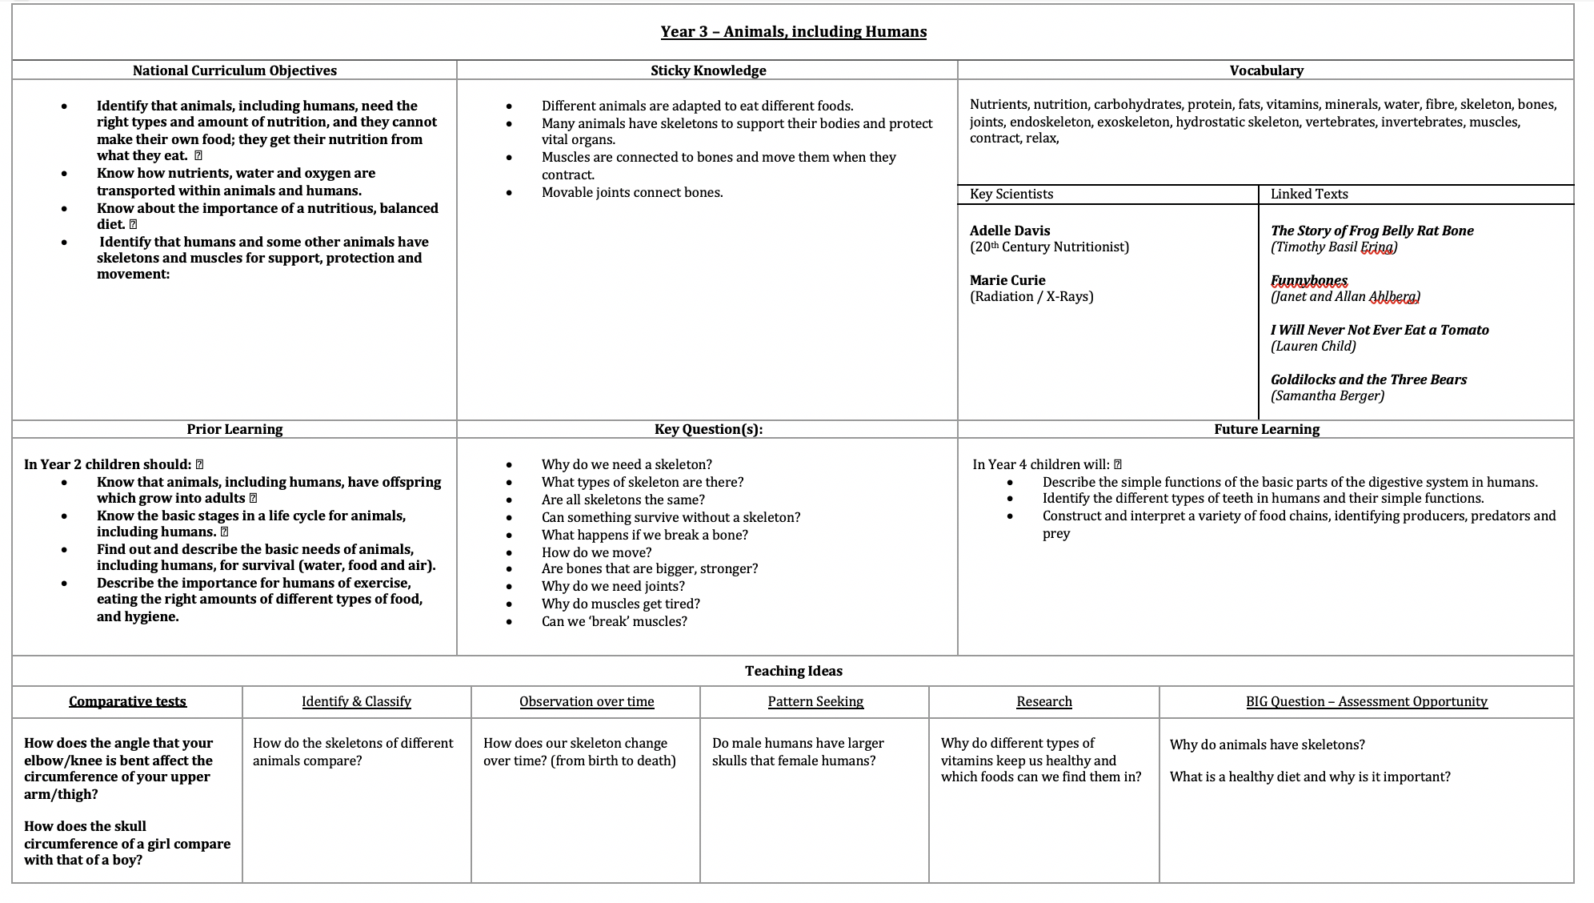When planning lessons, teachers ensure that National Curriculum objectives are covered, prior (and future) knowledge is considered and challenge is built in to allow children to make excellent progress. Key vocabulary is shared and used throughout lessons, key scientists are researched and cross-curricula links are achieved through exploring linked texts. Teachers will make learning purposeful by challenging children to link their knowledge and observations to help them answer a range of engaging BIG Questions. Teachers can access the wide range of lesson ideas available e.g The Ogden Trust and adapt to suit the individual ideas and interests of the children in their class.
Monitoring/Assessment:
- Assess prior knowledge- e.g quizzes, discussion, data from prior years.
- Exemplification materials- Primary Science Assessment (PLAN) available from The Association for Science Education.
- Exit points- Quizzes, end of unit assessments, Children’s written work, Children’s verbal contributions and ideas throughout each unit.
- Implement TAPS (Teacher Assessment in Primary Science)
- Use of assessment documentation to identify children, WTS, EXS and GDS
- Moderation within school hub
- Pupil Conferencing
- Learning Walk/Lesson Observations
- Work Scrutinies

Teaching and Learning Expectations:
- Science will be taught for 2 hours a week – where necessary, additional morning/afternoon sessions will be allocated
- All children are able to access Science learning.
- Support and challenge to be planned for and provided through ongoing assessment.
- Teachers to use skills progression documentation and exemplification materials to assess learners
- Each topic to include a variety of practical investigations to extend and consolidate learning.
- Teachers to ensure all types of ‘working scientifically’ skills are covered throughout the year (age appropriate)- Observing over time, Pattern seeking, Identifying and classifying, Comparative testing, Fair test, Research and Ideas over time.
- One piece of Science work recorded per week- this can include photos and children’s comments relating to science investigations.
- Class blogs and social media to include examples of Science work and activities.

Working Walls/Displays:
- All classes to display current Science learning. This should include the ‘BIG Question’ and work completed to work towards answering this.
- Key Science Vocabulary to displayed in classroom.
- Science Display in the KS2 block to celebrate examples of children working scientifically across the school.

