Subject Progression of Skills and Knowledge
Subject – British Values

Aspect of the  Curriculum | EYFS | Year 1 | Year 2 | Year 3 | Year 4 | Year 5 | Year 6
Individual Liberty | Begin to accept the needs of others in learning activities and take turns and share resources. | To understand that they are responsible for their own behaviour and apply this, particularly on school trips, or when visitors are in. | To know that individual behaviour can affect the quality of the local environment. | Use own  initiative to keep themselves safe e.g online safety | To know they can be responsible for developing own self-esteem  and self confidence through a growth mindset and mindfulness, living in the moment. | To know that individual behaviour can affect the quality of society more widely. | To know that they are responsible for their own behaviour, show initiative, and  understand how  they can contribute positively to the lives of those living and working in the locality of the school and to society more widely.
Rule of Law | To be able to follow the school and class code of conducts. | To understand the consequences of not following the school or class code of conducts. | To be know why we have a school and class code of conduct, in order to keep everyone safe and create a learning environment. | To know how the rule of law has changed over time. | To know how punishments have changed over time. | To know the difference between civil and criminal law. | To have an appreciation that living under the rule of law protects individual citizens and is essential for their wellbeing and safety.

Democracy | To participate in simple votes to choose things. | To understand the process and participate in school council election for the first time.  To know what Parliament is in simple terms. | To know some of the changes Parliament was able to make after The Great Fire of London and the Titanic in order to keep us safe. | To know how democracy looked different or the same in the past. | To know the responsibilities of the Houses of  Parliament  (House of  Commons),the executive seat of power. | To know how the Legislative power is held between the two Houses of Parliament (Lords and Commons). | To have an understanding of how citizens can influence decision-making through the democratic process. To have an understanding that there is a separation of power between the executive and the judiciary, and that while some public bodies such as the police and the army can be held to account through Parliament, others such as the courts maintain independence.
Mutual  Respect and Tolerance | To know own family customs and others from around the world. | To know some simple comparisons  between  countries in the world and their cultures. | To understand some gender stereotypes (through female astronauts) and how our class system has changed to equal opportunities. | To understand the similarities and differences between the lives of early people and us, specifically the difference | To understand people eat different foods in different cultures e.g Halal, vegan, bush food etc. To understand people have  different abilities | To know the similarities and differences between the cultures of different countries. | To have an understanding that the freedom to choose and hold other faiths and beliefs is protected in law. To accept that other people

 |  |  |  |  | between male and female ‘roles’ | e.g the ability to hear. |  | having different faiths or beliefs to oneself (or having none) should be accepted and tolerated, and should not be the cause of prejudicial or discriminatory behaviour. To have an understanding of the importance of identifying and combatting discrimination.
Spoken Language  (Oracy) | Children express  themselves effectively, showing awareness of listeners’ needs. They use past, present, and future forms accurately when talking about events that have happened or are to happen in the future. They develop their own explanations by |  | - Learn how to argue and defend points of view. (Ref: Promoting fundamental British Values as part of SMSC in schools (Nov. 2014).  - Listen and respond appropriately to adults and their peers ask relevant questions to extend their understanding and knowledge articulate and justify answers, arguments and opinions give well-structured descriptions, explanations, and narratives for different purposes, including for expressing feelings.  - Maintain attention and participate actively in collaborative conversations, staying on topic and initiating and responding to comments  - Use spoken language to develop understanding through speculating, hypothesising, imagining and exploring ideas participate in discussions, presentations, and debates consider and evaluate different viewpoints, attending to and building on the contributions of others (National Curriculum).

 | connecting ideas or events.
Cultural Capital | There are many ways in which we develop children’s cultural capital at Sandy Hill Academy. We believe it is important for them to be exposed to a variety of experiences, both linked with the National Curriculum subjects, and the wider world in order to develop aspirational goals for their futures.
Sandy Hill Values | 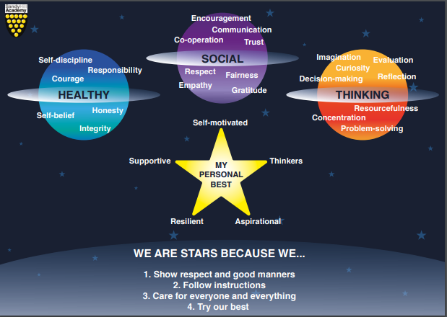  In the Early Years and KS1, children learn the 4 school rules alongside the My Personal Best Sandy Hill Star values. Once these are embedded during Early Years and KS1, KS2 children begin to learn the Planet values, focusing on different values per half term.

