Understanding the Mastery of Mathematics

Problem Solving (P) or Blue Maths
What does it mean?
Problem solving is the skill of applying maths skills to a new challenge in order to find the solution.

What does it look like in Year 1? – We problem solve every day!
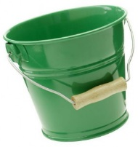
There are two flowers in each pot. How many flowers in 10 pots?
Use all 10 cubes. How many cubes in each bucket?
The blue bucket has one more cube in it than the red bucket.
The red bucket has three fewer cubes than the green bucket.

