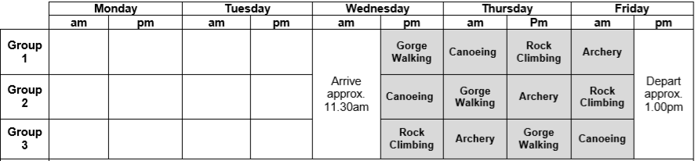
Year 5 Delaware Itinerary

