Understanding the Mastery of Mathematics

Problem Solving (P) or Blue Maths
What does it mean?
Problem solving is the skill of applying maths skills to a new challenge in order to find the solution.

What does it look like in Year 2? – We problem solve every day!
Fill in the missing numbers in the grid using 1, 2, 4 and 7.
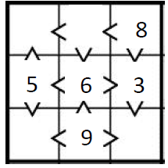
Complete the table
 | Tens | Ones
Forty four | 4
Forty six |  | 6
Sixty four | 6
Thirty four |  | 4

